Please join us at the
New Castle Public Library

Becoming Wolf: The Eastern Coyote in New Hampshire
Chris Schadler – M.S. Conservation Biology
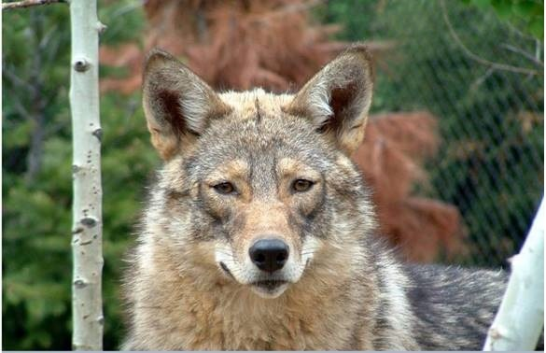

Wednesday, April 24th
3pm – 4pm

Chris Schadler, M.S., Conservation Biology, will discuss the ecology and behavior of our eastern coyote and how to live with the creature. Chris has over 40 years of wolf and coyote research, has farmed sheep successfully with coyotes as neighbors, and will demonstrate that “knowledge is power” when it comes to living with coyotes.

Myths surround the coyote and cloud our understanding of it. Our eastern coyote shares genes with the eastern wolf, the grey wolf, and the western coyote. Its hybrid nature enables its resilience and adaptability to live almost everywhere in New England. It has rewilded the northeast with its howl and ability to prey on large and small mammals. But despite its ecological benefits, it is the most persecuted carnivore in North America. And despite human efforts to eradicate it, it survives and thrives among us.
Please RSVP:
Christine Collins, Library Director
nwcstle.library@comcast.net
431-6773

