New Castle Public Library

Community Read

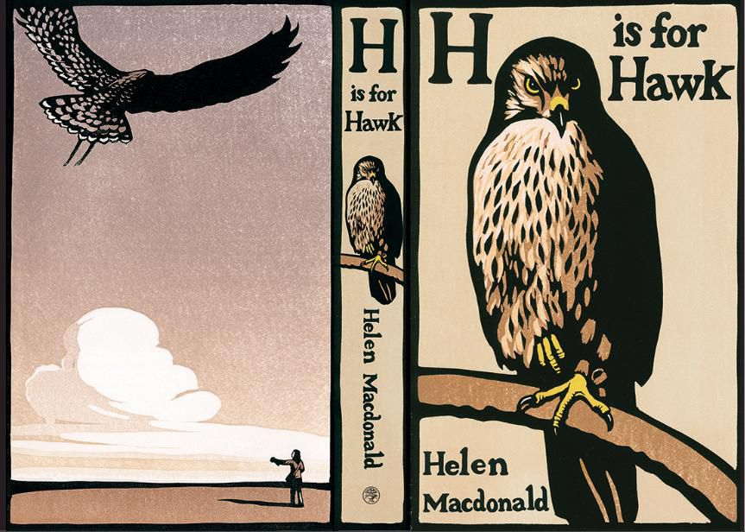

Discussion on
Wednesday, October 18th at 3pm 2023

Please join us to discuss H is for Hawk by Helen Macdonald. This will be great preparation for a program coming to the library the following week. Henry Walters, licensed master falconer and founder of Monadnock Falconry, will be at the library on Tuesday 10/24 at 10:30am. He will bring his hawk Mahood for an outdoor program on birds of prey.

Let me know if you would like to join us for the Community Read! The library has interlibrary loan copies of the book, stop in to pick up a copy.

Christine Collins, Library Director
nwcstle.library@comcast.net
431-6773

