The New Castle Public Library
Cookbook Club
Tuesday, April 30th at 11am
Library

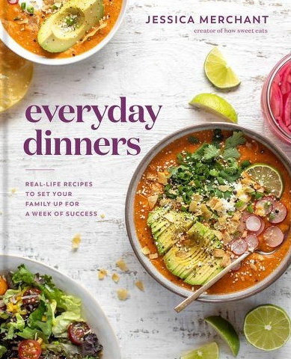

- Pick up a copy of the book at the library (we have interlibrary loans)
- Read the cookbook and try some recipes
- We will meet at the library to discuss the cookbook and share our favorite recipes

Please RSVP:
Christine Collins, Library Director
nwcstle.library@comcast.net
603-431-6773

