New Castle Public Library

A History of Portsmouth NH in 101 Objects
Kathleen Soldati, Editor
Stephanie Seacord, Project Director
Wednesday 5/8/24 from 3-4pm

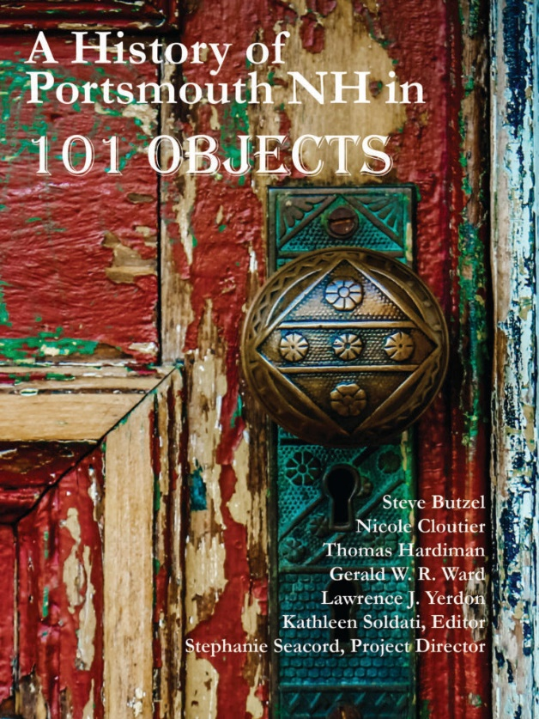

A History of Portsmouth NH in 101 Objects is a crowd-sourced compendium of objects and ideas the people of Portsmouth selected as those most important to the story of the city as it celebrated its 400th anniversary. The book presents images of 101 objects important to Greater Portsmouth’s history, matched with intriguing texts from eighty local authors to celebrate Portsmouth’s unique, diverse, and wide-ranging history. Stephanie Seacord and Kathleen Soldati worked with the directors of the Portsmouth Athenaeum, Portsmouth Historical Society, Portsmouth Public Library, and Strawbery Banke Museum and asked them to nominate objects. The program will discuss this process and the objects chosen (including some New Castle connections). What is important to us 400 years after European settlement?

Please RSVP:
Christine Collins, Library Director
ccollinsnclibrary@gmail.com
(603-431-6773)

