The New Castle Public Library

will be showing the movie

The HUNDRED-FOOT JOURNEY
Friday, April 19th at 2pm

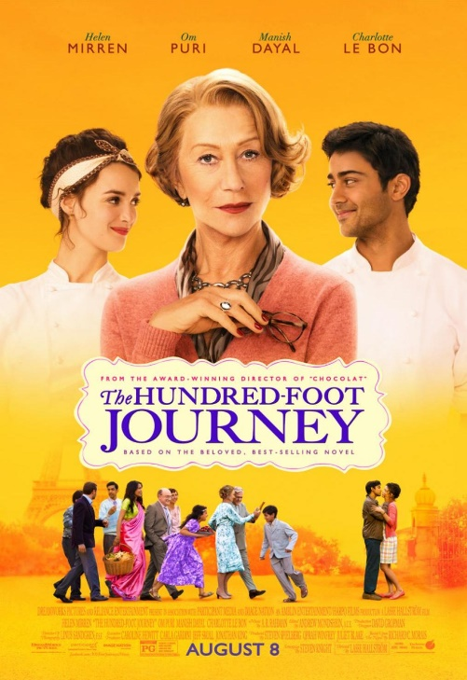

Hassan Kadam (Manish Dayal) is an extraordinarily talented, self-taught culinary novice. When he and his family are displaced from their native India and settle in a quaint French village, they decide to open an Indian eatery. However, Madame Mallory (Helen Mirren), the proprietress of a Michelin star restaurant just 100 feet across the street, strongly objects. War erupts between the two establishments.

Running time: 2 hours

Christine Collins, Library Director
ccollinsnclibrary@gmail.com 603-431-6773

