Healthy Living series
Drop-in Pickleball

March – May 2024
Tuesdays & Thursdays 1:30-3:30pm
(in the New Castle rec center)
NOTE: No Pickleball on Tuesday, May 14th (Town Meeting)

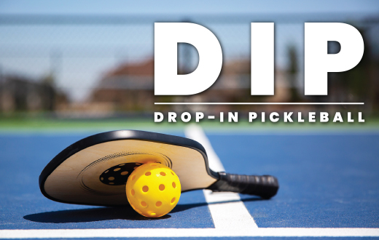

We are continuing drop-in Pickleball for the next few months. We will revisit the schedule in June. This is not an instructional program, players should have a little experience and know the basic rules. Come have some fun, cheer on your partner and opponents, and get some good exercise. Open to New Castle residents and friends.

Co-sponsored by New Castle Public Library & Recreation Committee

Christine Collins, Library Director
ccollinsnclibrary@comcast.net
603-431-6773

