Healthy Living series
Yoga

May 2024

3-week session: Tuesdays ~ 5/21, 5/28 and 6/4

8:30-9:45am ~ Rec Center

Mary-Jo Antosca will lead us in another Yoga program! Mary-Jo is a certified yoga instructor who teaches Vinyasa style Yoga. Bring a yoga mat, water bottle, and small towel. Wear comfortable clothing. The class is open to adults, ALL levels are welcome. There is no charge for this program.

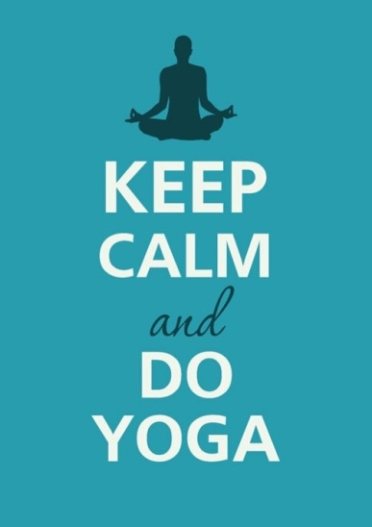

RSVP required:
Christine Collins, Library Director
nwcstle.library@comcast.net
431-6773

