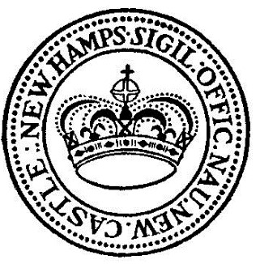

TOWN OF NEW CASTLE, NH
PLANNING BOARD – LEGAL NOTICE
PUBLIC HEARING – MASTER PLAN
Posted on February 15, 2024

Notice is hereby given that there will be a Public Hearing with the New Castle Planning Board at 7pm on Wednesday, February 28, 2024, in the Macomber Room, 301 Wentworth Road, New Castle, NH.

Subject of the Public Hearing is acceptance of the proposed MASTER PLAN for New Castle to be voted on by the Planning Board.

A full copy of the Master Plan is posted on the Town’s website https://www.newcastlenh.org under the “Town News” tab and available at the New Castle Town Office, 49 Main Street, during regular business hours.

