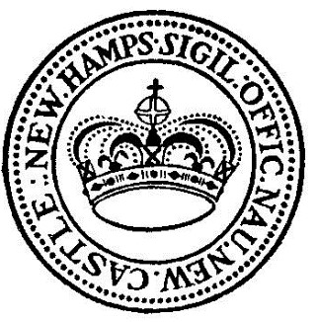

Ocean Street Property Advisory Committee Agenda

DATE: February 8, 2024
Time: 9:00 AM
Meeting location: Town Hall Conference Room, 49 Main Street (In person)

- Call to order
- Discussion
- Other Business
- Next Meeting
- Adjournment

