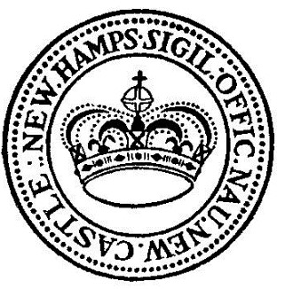

Ocean Street Property Advisory Committee Agenda

DATE: February 15, 2024
Time: 9:00 AM
Meeting location: Town Hall Conference Room, 49 Main Street (In person)

- Call to order
- Review and Approve Minutes from 8 Feb 2024 Meeting
- Discussion:
  - Discussion of Property Tour
  - Discussion of Property Fact Sheet (provided via email)
  - Envelope and mailing support activities
- Public Discussion/Questions
- Next Meeting
- Adjournment

