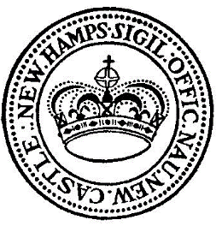
Town of New Castle
PO Box 367
49 Main Street
New Castle, NH 03854
603-431-6710, ext 2; fax 603- 433-6198

Presidential Primary Results
January 23, 2024

DEMOCRAT
Jason Michael Palmer | 1
Dean Phillips | 18
Donald Picard | 1
Marianne Williamson | 5
Terrisa Bukovinac | 1
Derek Nadeau | 3
WRITE-IN’S
Joe Biden | 159
Nicky Haley | 7
Other | 2
REPUBLICAN
Donald J. Trump | 96
Doug Burgum | 1
Chris Christie | 7
Ron DeSantis | 6
Nicky Haley | 260
Mary Maxwell | 1
WRITE-IN’S
Joe Biden | 1

Respectfully submitted,
Lisa K. English
Town Clerk, New Castle, NH

