Notice of Decision

New Castle Planning Board
49 Main Street, PO Box 367, New Castle, NH 03854-0367

Map: 11
Lot: 23
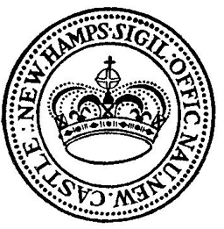
Telephone (603) 431-6710 Fax (603) 433-6198

Date: January 26, 2024

Applicant: Luis A. Rivas and Valeria L. Rienzi

Location: 35 Grist Mill Lane, Map 11, Lot 23

At the January Planning Board meeting held on January 24, 2024 the Planning Board voted unanimously to APPROVE a Conditional Use Permit for the applicant for construction of an attached Accessory Dwelling Unit as presented in the Charles Hoyt Designs plans dated January 2, 2024. Approval is based on the applicant having met all criteria for a Conditional Use Permit for an ADU as stipulated in the New Castle Zoning Ordinance Section 6.6.5.

Signed: _______________________________________
P. Darcy Horgan
Planning Board Chairman

cc: Applicant
Building Inspector
Selectmen
Town Files
Town Clerk

